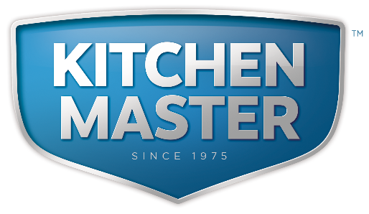

Kitchenmaster | 11 Comber Road | Carryduff | Belfast | BT8 8AN Email: sales@kitchenmaster-ni.com Web: www.kitchenmaster-ni.com
Head Office: 028 9081 4777
PRODUCT GUIDANCE SHEET

HAND DISHWASH DETERGENT ALDET

CONCENTRATED NEUTRAL DETERGENT

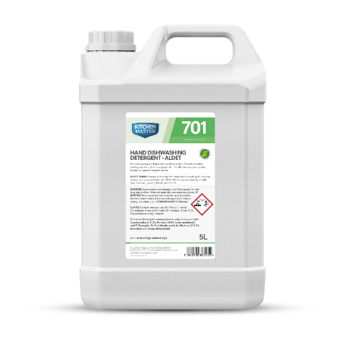

A powerful concentrated neutral detergent. Primarily used as a manual washing up liquid in commercial kitchens where high volume used requires ultimate control. It can also be used at high dilutions for general hard surface and floor cleaning.

Product Name: HAND DISHWASH DETERGENT ALDET
Description: Concentrated odourless neutral detergent Pack Size(s): 4X5 Lt & 2x5Lt
Pallet Size(s): 40 &80
Product Code(s): WULALDET

HOW TO USE
Used for washing up pans, utensils and other catering equipment that will not fit into the dishwasher. Designed to remove starches, grease and stubborn residues from larger catering utensils. Remember, highly soiled items should be soaked in a hot water and chemical solution before normal washing up commences.

Caution:
This product is designed to degrease plates and utensils, so it will de-fat hands also with prolonged use without protective clothing. Please ensure you wear rubber gloves at all times.

HAND DISHWASH DETERGENT ALDET must be diluted before use using an over-sink dispenser. For a sink cleaning solution add two to four plunges of dispenser to a sink of water depending on the degree of soiling.

Cross-Contamination Prevention
Premises should note that if there is no ability to gain thermal disinfection through an automatic dish or glass washing machine, to avoid a risk of cross contamination, a two-stage cleaning and disinfection washing up process as best practice:

Issue Date: March 2021

Kitchenmaster products are manufactured under ISO 9001 registered Quality Management System.

Stage 1 Cleaning: Remove food debris then manually wash dishes or equipment and allow sufficient time for the product to penetrate the soiling, agitating heavily soiled areas if necessary. Rinse with fresh clean water or wipe down with a clean damp cloth.

Stage 2 Sanitising: In a separate sink prepare a disinfectant solution which meets BS EN 1267 standard. Immerse washed items into the disinfection solution and allow sufficient contact time before rinsing the surface with fresh clean water or a clean damp cloth. Allow to air-dry or dry the surface with a separate clean dry cloth.

SAFETY ADVICE
Warning. Causes serious eye irritation. Harmful to aquatic life with long lasting effects. Wash exposed skin thoroughly after handling. Avoid release to the environment. Wear protective gloves/ protective clothing/eye protection/face protection. IF IN EYES: Rinse cautiously with water for several minutes. Remove contact lenses, if present and easy to do. Continue rinsing. If eye irritation persists: Get medical advice/attention.

For detailed advice on safe handling and storage of the concentrated product refer to the product Safety Data Sheet.
Keep out of reach of children. FOR INDUSTRIAL & INSTITUTIONAL USE ONLY.



COSHH STATEMENT
COSHH is a law that requires all employers to take steps to control substances (chemicals) that may cause harm to employees, contractors and visitors to the workplace. Every work environment will be different in terms of the hazardous chemicals that are present, and how these are used, and individual assessments may be necessary to consider how chemicals can be handled and stored safely, in addition to ensuring that appropriate PPE and training is provided for employees. Product MSDS and Product Guidance Sheets are intended to help when carrying out a COSHH assessment, however if further advice is needed with regard to specific issues in your work environment we are happy to provide advice. E-Mail Technical: sales@kitchenmaster-ni.com

